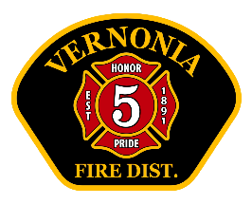
Vernonia RFPD Chief’s Report
December 2025

Operations:
- Total calls for service: 62. 2025 YTD: 668 (2024 YTD 633)
- No major issues with equipment.
- Vehicle chains checked for winter
- Interesting/significant calls:
- Malfunctioning appliance- Carbon Dioxide leak.
- Fatal car crash Hwy 47 N
- Vehicle crash with car fire Hwy 47 N (no injury)
- MVC- car into 250 Gal. Propane tank. Evacs initiated. Crews on scene 5.5 hours

Training (internal and external)
- Training topics: NFPA Driver/ Forcible entry (prop)/ various EMS scenarios
- Total man-hours of VFD training: 232 (includes hours of community event- pancake feed)
- Upcoming training: Vehicle extrication, SCBA, Entrapment/ FF safety and survival/ EMS

Administrative:
- Several Volunteers have donated time to stand-by the station and “pull shift”. This is defined as a volunteer here, on-duty, in uniform and ready to respond. Total hours- 199.5. It should be noted that most of these volunteers are trainees, and not certified firefighters or EMT’s.
- New SCBA’s here. Just finishing up inventory. Will be in service any day.
- Met with contractor for LZ design at Vernonia Airport
- Working with Lyons Club to initiate our OSFM smoke detector distribution program
- Busy month for many activities
- Chief’s schedule out of town:
  - OFCA small dept roundtables Jan 9-10 Eugene
  - January 21-23- California (family)
  - January 30-Feb 1 Lincoln City (Vacation)
- Bond - Paid in Full on December 18, 2025
- Lt. Tannery will be taking a nationally recognized PIO course in February

