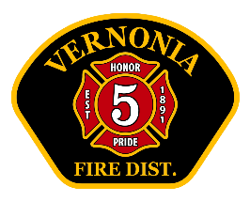
Vernonia RFPD Chief’s Report
August 2025

Operations:
- Total calls for service: 72. 2025 YTD: 419 (2024 YTD 425)
- No major issues with equipment, other than long lost bill from 2023 paid
- Interesting calls:
- House fire on Fir Street August 21st. Good stop initiated by Lt. Abney. Assistance from Mist-Birkenfeld Fire appreciated.
- Significant gas leak from a punctured gas line on Noakes Rd August 18th.
- Fully involved vehicle fire
- Three people life flighted from the area
- Assisted two simultaneous calls with outside agencies at same time.
Training (internal and external)
- Training topics: Water Rescue, Sports Injuries, Building Walk-through (WOEC), Vehicle extrication, Cardiac arrest
- Total man-hours of VFD training: 171 hours
- Upcoming training: Officer training, initial attack, Ropes and knots, EMS

Administrative:
- Several Volunteers have donated time to stand-by the station and “pull shift”. This is defined as a volunteer here, on-duty, in uniform and ready to respond. This includes time put in by Deputy Chief Meyer. Total hours- 145.5. It should be noted that most of these volunteers are trainees, and not certified firefighters or EMT’s. Hours are down as expected due to summer activities.
- Summer staffing grant going well. Two have resigned due to conflicting full-time job issues. Expect program in place until October 12th.
- Audit preparation underway

- VFD hosting a “Women in the fire service” seminar October 16th.
- Two volunteers have resigned due to work conflicts.
- Lt’s Abney and Tannery helping to instruct at Portland Metro Fire Camp for girls.
- October 4th Red Cross Blood drive
- September 11th remembrance walk-through town.
- Recognize Andy Boser

