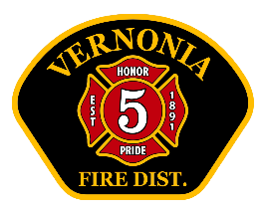
Vernonia RFPD Chief’s Report
June 2025

Operations:
- Total calls for service 64 (41 EMS / 5 Hazardous Conditions/ 10 Service calls/ 5 Good Intent calls/ 2 False calls) YTD: 295
- No major vehicle issues in June.
- Interesting calls:
- 1 out of area assist (Mist-Birkenfeld) brush fire
- 2 Motor Vehicle Crashes. Both submitted for reimbursement (out of district residents).
- Three reported Natural gas leaks investigated (stood by for NW Natural crews)
- Over $6,000 spent on needed safety and PPE equipment (flashlights / wheel chocks/ boots, gloves, ect.)

Training (internal and external)
- Training topics: Flammable Liquid and Gas exercises / SCBA demonstrations / Wildland hose lays/ Drafting / Narcan
- Total man-hours of VFD training: 165
- Upcoming training: SCBA / hose lays/ quick-attack

Administrative:
- Several Volunteers have donated time to stand-by the station and “pull shift”. This is defined as a volunteer here, on-duty, in uniform and ready to respond. This includes time put in by Deputy Chief Meyer. Total hours- 242. It should be noted that most of these volunteers are trainees, and not certified firefighters or EMT’s
- 7 additional firefighters have started on staff this summer. Most of the time it will add one FF per day from 0800-2000. We will “upstaff” over Independence Day and Jamboree. The staffing includes one paramedic, two EMT’s, and one EMR. Extra staffing will allow us much more training, cleaning, upkeep and public-relations opportunity.
- New pickup from Hillsboro Fire has arrived.
- Station AC units fixed. No cost. Manufacturing defect.
- No policy updates this month as the Chief was gone much of June.
- Chief working on project to bring station parking lot up to ADA standards.
- Grant update___________

