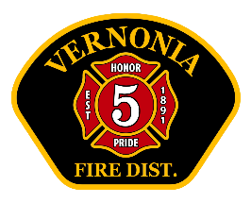
Vernonia RFPD Chief’s Report
September 2025

Operations:
- Total calls for service: 70. 2025 YTD: 489 (2024 YTD 468)
- No major issues with equipment.
- Interesting calls:
- 2 Natural gas leaks (one significant- contactor on Bridge St- billed)
- One injury MVC
- 2 mutual aid brush fire calls
Training (internal and external)
- Training topics: Fire/EMS Trivia game, Building Construction, Forcible entry, Earthquake review, Haz-Com, Pump theory and operations
- Total man-hours of VFD training: 169 hours
- Upcoming training: Vehicle extrication, Forcible entry, EMS, Life Flight (October 13- board welcome)

Administrative:
- Several Volunteers have donated time to stand-by the station and “pull shift”. This is defined as a volunteer here, on-duty, in uniform and ready to respond. Total hours- 146. It should be noted that most of these volunteers are trainees, and not certified firefighters or EMT’s. Hours are down as expected due to summer activities.
- Summer staffing grant going well. Two have resigned due to conflicting full-time job issues. Expect program in place until October 25th.
- Audit preparation underway
- VFD hosting a “Women in the fire service” seminar October 16th.
- Chief Meyer has resigned for personal reasons.
- Lt’s Abney and Tannery helped to instruct at Portland Metro Fire Camp for girls. Went well- great networking.
- October 4th Red Cross Blood drive- exceeded goal
- Chief Officer coverage- Scappoose.
- OSHA invited here for consult on October 10th
- New Handicapped parking spot marked. Parking signs installed
- 5-star contacted about extending handrail

