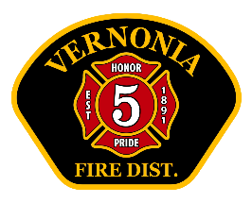
Vernonia RFPD Chief’s Report
November 2025

Operations:
- Total calls for service: 55. 2025 YTD: 606 (2024 YTD 592)
- No major issues with equipment.
- Slowly updating our logo to all rigs.
- Interesting calls:
- 2 Minor injury MVS’s north of town
- One major crash south of town (car vs. elk)
- Mutual aid to MBFD- overturned log truck non injury

Training (internal and external)
- Training topics: Officer development, Forcible entry, Lithium battery safety, Medical assessment, MSA SCBA use and hose deployment
- Total man-hours of VFD training: 188
- Upcoming training: Vehicle extrication, Hydrants, SCBA, Communications, Rehab
- Chief taught drivers course 12/6-7-2025 16 hours and 8 students from three agencies.

Administrative:
- Several Volunteers have donated time to stand-by the station and “pull shift”. This is defined as a volunteer here, on-duty, in uniform and ready to respond. Total hours- 106.5. It should be noted that most of these volunteers are trainees, and not certified firefighters or EMT’s.
- I attended OFDDA conference with President Kennedy and Member Weller. Good information.
- Gearing up for Christmas community activities and wintertime weather. Checked chains on all rigs.
- We have started to receive new SCBA supplies. Much more remains to be delivered.
- We have been asked to put on a “safety fair” of sorts for the Nehalem Valley Bible Church next April. Delighted to do so.
- Next federal fiscal year, we will apply for a new fire engine on one grant, and a separate, regional grant for radios.
- I have informed staff to immediately reduce spending to only necessary, daily operating supplies. I would like this pause to last several months to maintain our budget. We are OK, but I am a worrier.

